**PROJECT REPORT**

**ANALYSING HOUSING PRICES IN METROPOLITAN AREAS OF INDIA**

**TEAM DETAILS :**

**TEAM LEADER : K.ARULARASI**

**TEAM MEMBERS : S.DHIVYA, K.KEERTHANA, S.SHOBA**

**1 .INTRODUCTION :**

**1.1 Overview:**

**The House Price Index (HPI) is a broad measure of the movement of single-family property prices in the United States. Aside from serving as an indicator of house price trends, it also functions as an analytical tool for estimating changes in the rates of mortgage defaults, prepayments, and housing affordability.**

**1.2 Purpose:**

**Prediction house prices are expected to help people who plan to buy a house so they can know the price range in the future, then they can plan their finance well.**

**2. PROBLEM DEFINITION & DESIGN THINKING :**

**2.2 Empathy Map:**

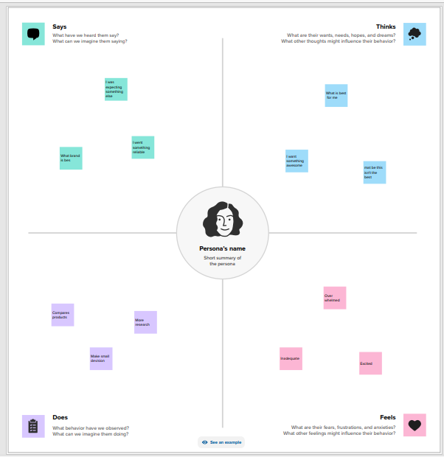

**2.2 Ideation & Brainstorming Map :**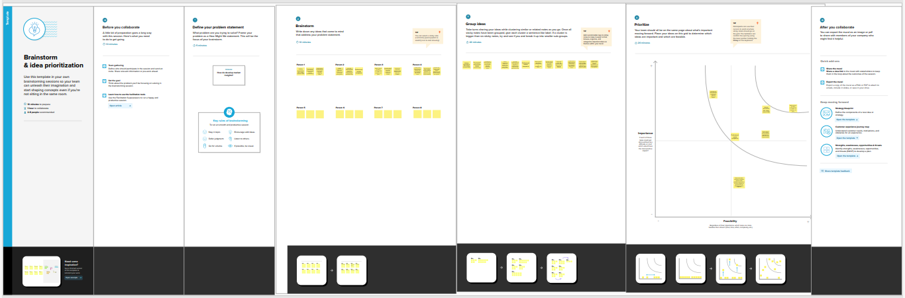

**3. RESULT :**

**DASHBOARD:**

**Dashboard 1 :**

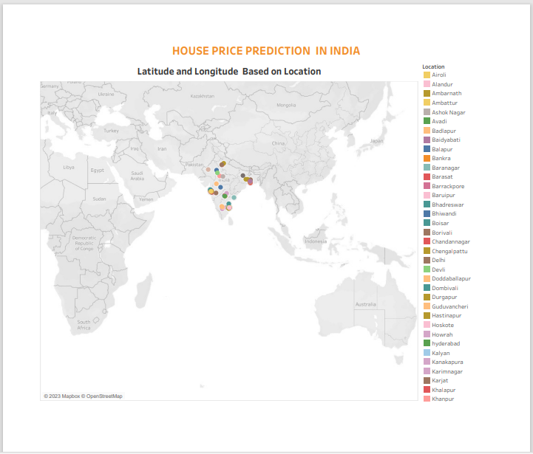

**Dashboard 2:**

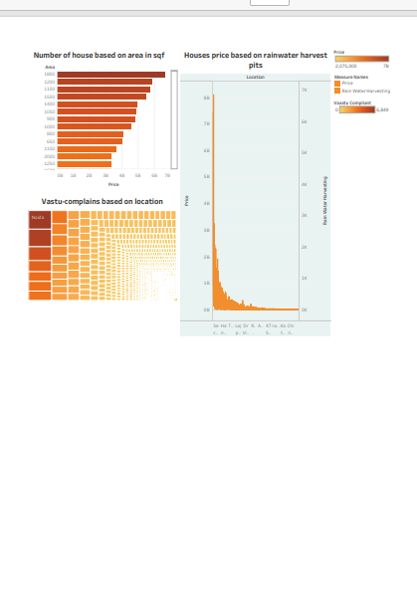

**Dashboard 3:**

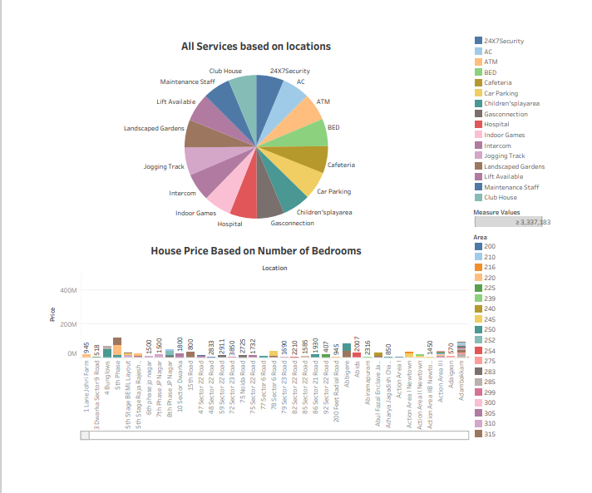

**Dashboard 4:**

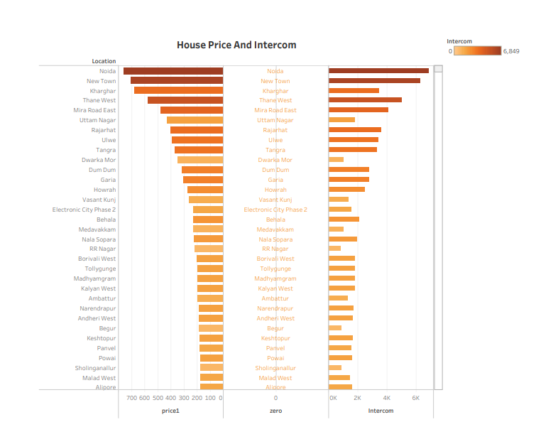

**Story 1:**

**Latitude and longitude based on location**

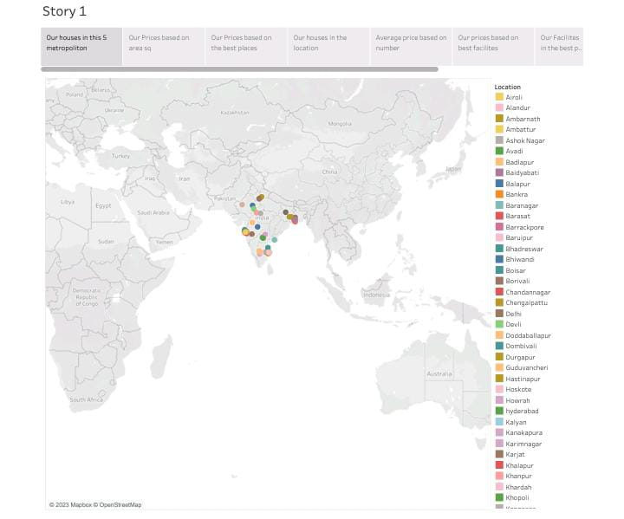

**Number of house based on area in sqf**

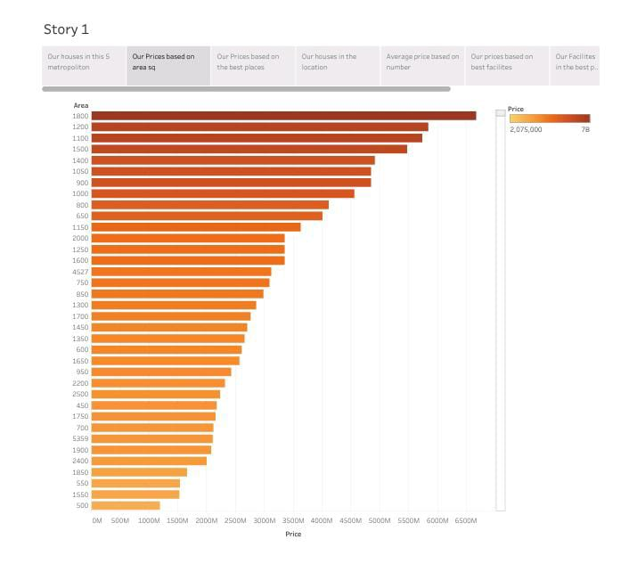

**Houses price based on rainwater harvest**

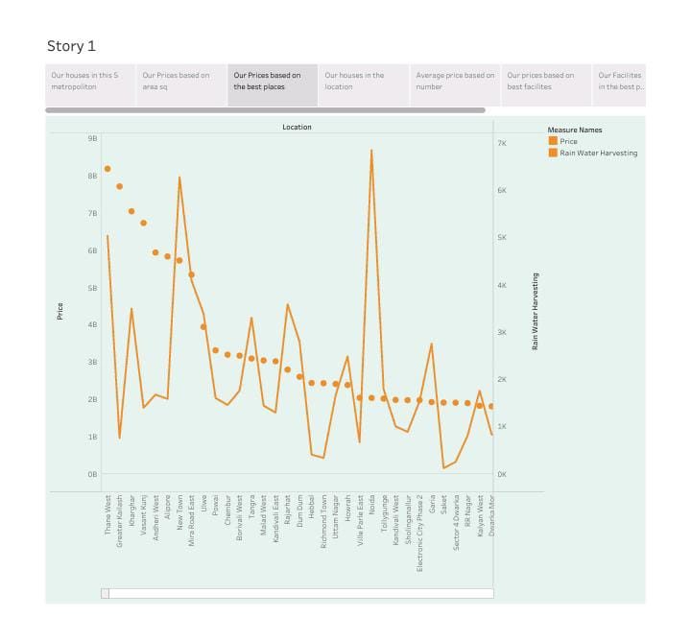

**Vastu-complains based o location**

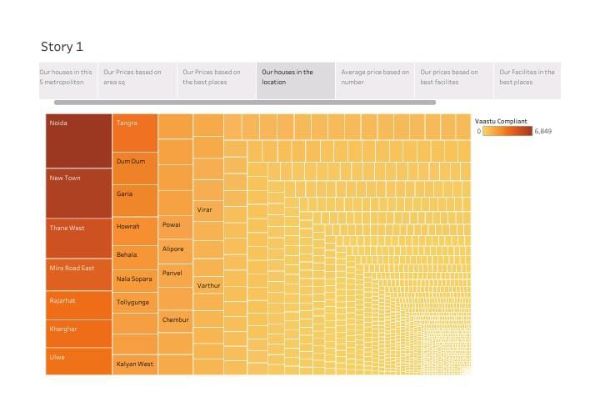

**House price based on number of bedrooms**

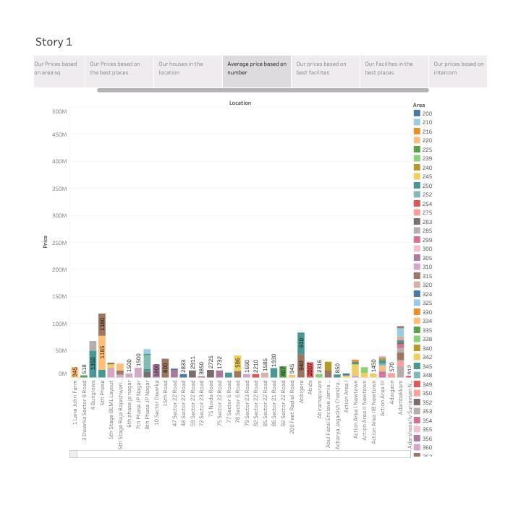

**Hospitals and schools near the houses**

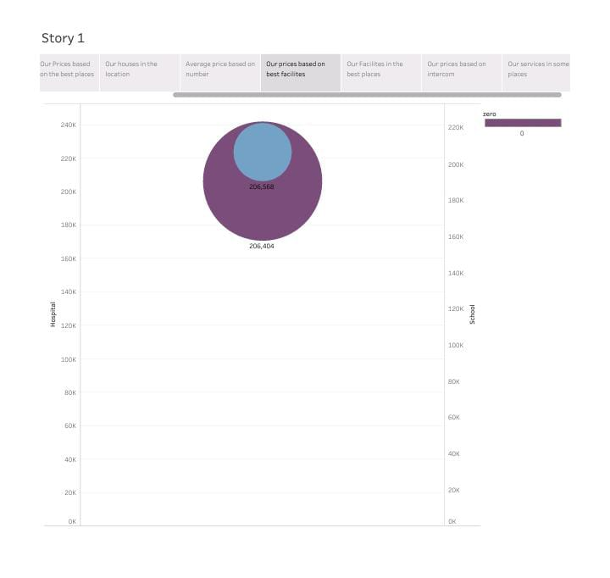

**Maintains staff in houses prices**

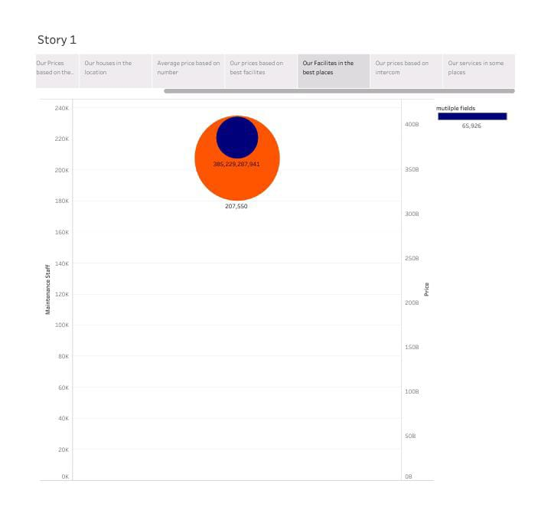

**House price and intercom**

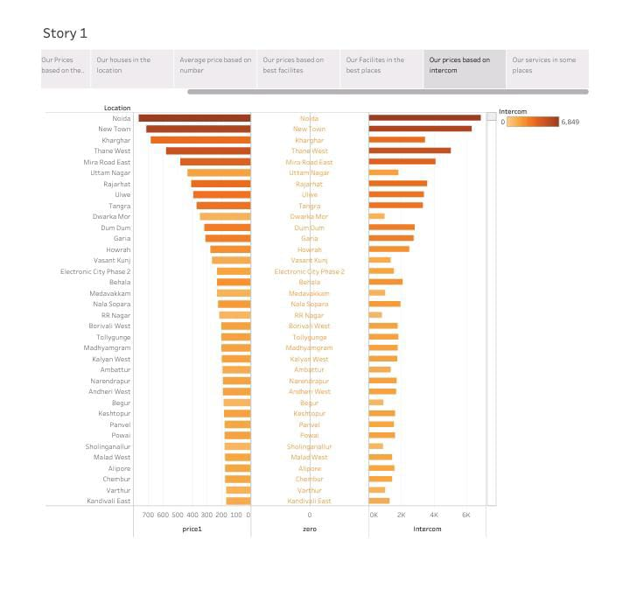

**All services based on location**

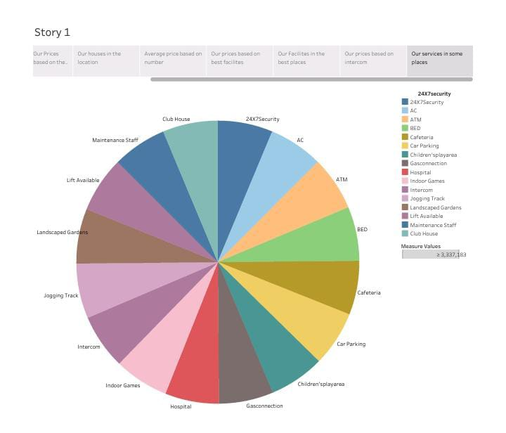

**4. ADVANTAGED & DISADVANTAGES :**

**Advantages :**

* **Lower construction coset compared to conventional one**
* **Lower home maintenance coset**
* **Checked for a multi-years housing system**
* **Better use of the terrain spatial potential**
* **Resistance to earthquakes in extreme weather conditions**
* **Fire resistance**

**Disadvantages :**

* **Psychical barriers –especially in constructions without windows**
* **In many cases , too small amount of the day light**
* **Poor design of the building may appear problems with ventilation and air quality in individual rooms**
* **In the case of poor building insulation problems with moisture , rodents and insects may occur**
* **During the flood there is a possibility off drowning inhabitants in the underground house**
* **There is a possibility of house collapsing in cade of structural defects and misuse the area above the house (roof,roof,with woody vegetation)**

**5. APPLICATION :**

**The purpose of this paper is to explore the nature housing price difference in metropolitan area . Factore that affect house price in are investigated by hedonic regression model with spatial variables.house price taken in natural log form as dependent variable and house characteristics,neighborhood characteristics and transportation infrastructure taken as independent variables.**

**6. CONCLUSION :**

**We are able to predict house price with around 90% accuracy for most of the cases and we have a good R-square of 0.83, which means 83% of the variability is explained by the model and we are also to explain the interpretation of the estimates of the model.**

**7. FUTURE SCOPE :**

**In future we can also include,latitude,longitude and elevation of the house in the model to predict the house price with more accuracy.future work can also include demographics variable like income,number of children,education,age of the family group etc in the model. To explain the variability in the house pricing and to predict house pricing more effectively.**